**Types of Inheritance in Java – Single,Multiple,Multilevel,Hierarchical & Hybrid**

Below are the different types of inheritance which is supported by [**Java**](https://www.javainterviewpoint.com/category/core-java/).

* Single Inheritance
* Multiple Inheritance **(Through** [**Interface**](https://www.javainterviewpoint.com/interface-java/)**)**
* Multilevel Inheritance
* Hierarchical Inheritance
* Hybrid Inheritance **(Through Interface)**

## ****1.**** [Single Inheritance in Java](https://www.javainterviewpoint.com/single-inheritance-in-java-with-example/)

Single Inheritance is the simple inheritance of all, When a class extends another class(Only one class) then we  call it as **Single inheritance.**

The below diagram represents the single inheritance in java where **Class B** extends only one class **Class A.**

Here **Class B** will be the **Sub class** and **Class A** will be one and only **Super class**

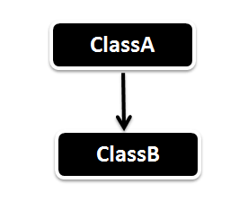

**public** **class** SingleInheritance {

**public** **static** **void** main(String[] args) {

// Assigning ClassB object to ClassB reference

B b = **new** B();

// call dispA() method of ClassA

b.dispA();

// call dispB() method of ClassB

b.dispB();

}

}

**class** A {

**public** **void** dispA() {

System.***out***.println("disp() method of Class A");

}

}

**class** B **extends** A{

**public** **void** dispB()

{

System.***out***.println("disp() method of Class B");

}}

Output

disp() method of Class A

disp() method of Class B

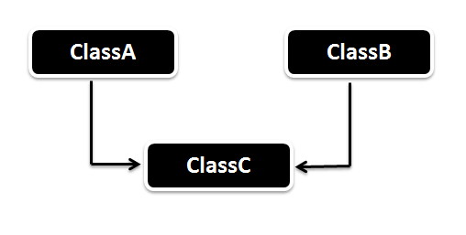

<https://www.javainterviewpoint.com/single-inheritance-in-java-with-example/>